Dairy Product Sales Analysis Dashboard
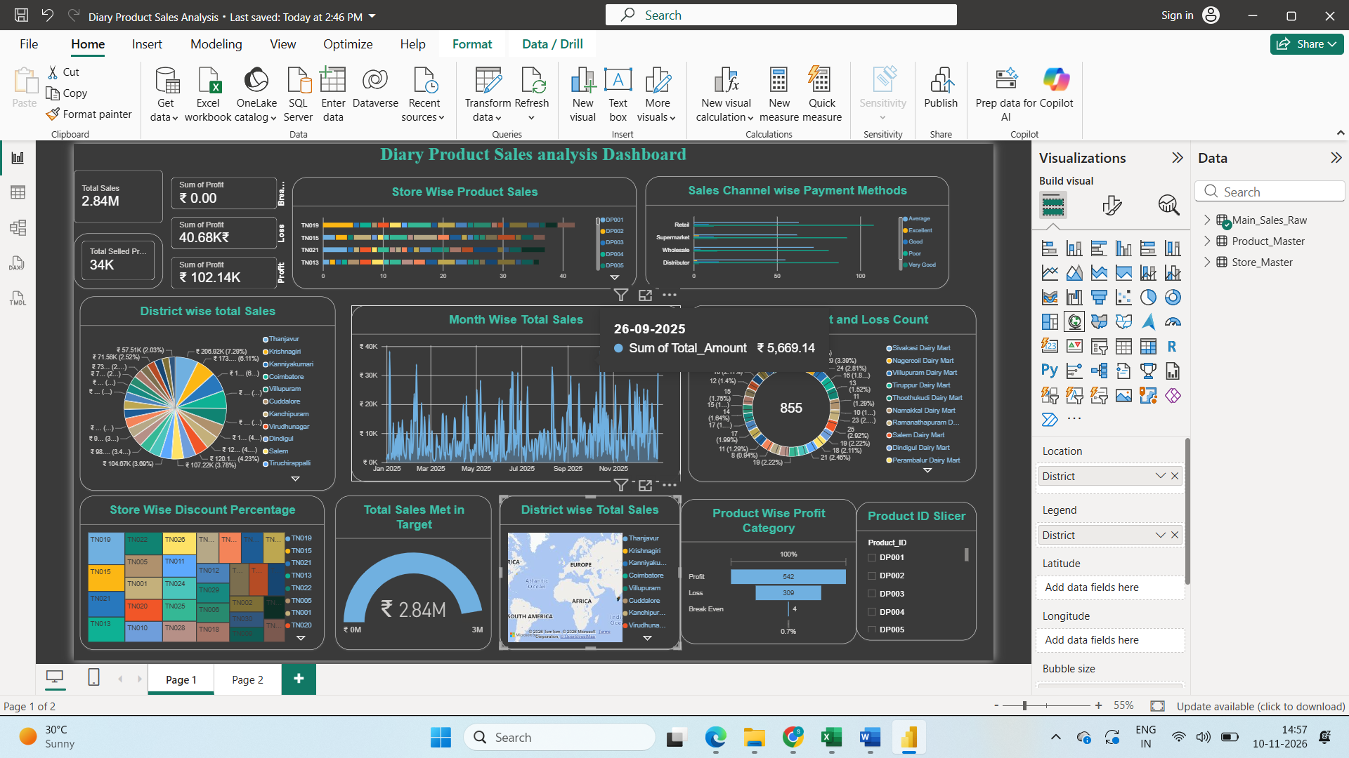
Product and Store Insights Dashboard


